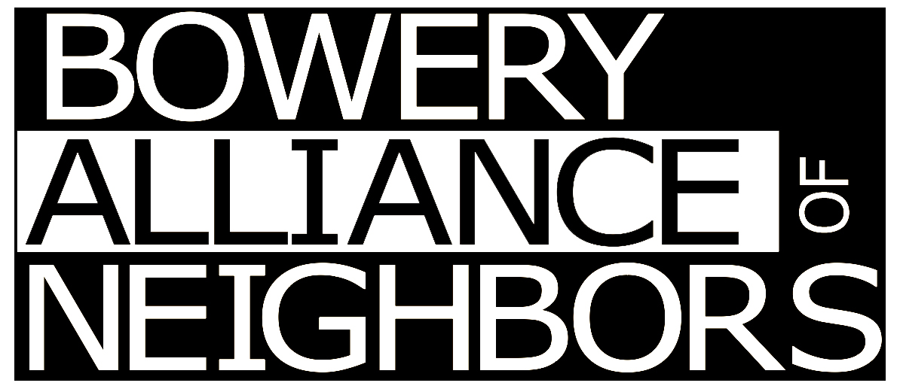
184 Bowery #4 NY, NY 10012
www.boweryalliance.org
Mitchell Grubler, Landmarks Committee Chair
mitchellgrubler@yahoo.com 917-651-9513

President
David Mulkins

Vice Presidents
Michele Campo
Jean Standish

Secretary
Sally Young

Treasurer
Jean Standish

Landmarks Committee Chair
Mitchell Grubler

Co-Founders
Anna L. Sawaryn
David Mulkins

Board of Advisors:

Kent Barwick
President Emeritus
Municipal Arts Society

Leo Blackman
Architect

Kerri Culhane
Architectural Historian

Eric Ferrara
Historian & Director
Lower East Side History Project

Pi Gardiner
Executive Director
Merchant’s House Museum

Bob Holman
Poet & Proprietor
Bowery Poetry Club

Lucy Sante
Historian

August 12, 2025

RE: Most Holy Redeemer Church, 173 East 3rd Street

Hon. Sarah Carroll, Chair
NYC Landmarks Preservation Commission
253 Broadway, 11th Floor
New York, NY 10007

Dear Chair Carroll:

The Bowery Alliance of Neighbors supports the campaign of Village Preservation to urge the LPC to designate the Most Holy Redeemer Church at 173 East 3rd Street as an Individual Landmark. Established by the Redemptorist Fathers in 1844 to serve New York City’s sizable German immigrant population at a time when this section of the East Village was known as Kleindeutschland, or “Little Germany,” the church has remained a cornerstone of the East Village community for over a century and a half. The Bowery Alliance of Neighbors catchment area shares in the rich history of Kleindeutschland.

The building, dating to 1852, features a mix of Baroque-Romanesque and Byzantine Revival styles. Although the original 250-foot-tall tower was lowered in 1902 it continues to remain an important marker in the East Village skyline. This important historic property is worthy of designation and preservation. We are especially concerned about the future of this building because the church has recently halted masses at the site.

Thank you for your consideration of this urgent matter.

Sincerely,
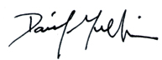
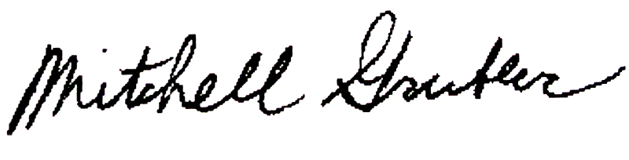

Mitchell Grubler, Chair David Mulkins, President
Landmarks Committee

